2011 Chairman’s Essay
We are MARS; FIRST team 2614 Mountaineer Area RoboticS. In the fall of 2009, we crafted a plan to spread FIRST throughout West Virginia (WV). The WV Plan was motivated by 3 facts. First, only 16% of WV high school freshman go on to any form of higher education, less than half the national average. Second, the Brandeis study showed that FIRST participants are nearly twice as likely to attend college as their equally matched peers and are twice as likely to major in STEM fields. Third, all MARS’ graduates have gone on to college with some form of scholarship. Based on our team’s success and the need for similar programs in the state, our team has decided to focus on developing a model for building sustainable FIRST programs in rural, underserved communities. Our goal is to make a FIRST program available to every student in WV.
To achieve this, MARS compiled demographic and economic data for each of WV’s 55 counties. Over the last decade, four WV FRC teams have folded, some after only one year of activity. Areas unable to sustain an FRC program due to demographic or financial limitations may be better able to support an FTC team. The WV Plan addresses sustainability issues by developing a network of overlapping “mentoring” regions where rookie FRC teams can gain support from existing teams.
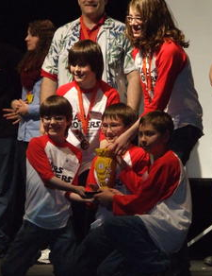
The WV Plan also involves expanding our thriving FLL program. We support 27 teams in 13 WV and Pennsylvania counties, including at least one team in every local middle school in our city. To eliminate teacher apprehension about starting a robotics team, MARS raises funds to register new teams and provides local teams with LEGO MINDSTORMS kits. MARS high school students provide bi-weekly, region-wide mentoring sessions during the FLL season. Some teams travel an hour to attend these sessions, which give coaches a chance to network and share ideas. MARS also organizes an annual scrimmage to allow teams to practice competing before the State Tournament. At the scrimmage, which is entirely run by MARS youth, sponsors serve as our judges so they can see the impact of their support for MARS on the community. Our team makes sure that every FLL team leaves with an award and a MARS patch! The scrimmage also serves as the venue for our annual food drive for local food pantries; this year the team donated over 500 items of food. At the state FLL competition in Wheeling, WV, MARS members serve as judges, referees, and volunteers. In the spring of 2010, MARS even hosted a make-up tournament for WV FLL teams who missed the state competition because of a snow storm. In addition, we host an annual step-up-to-FRC day for FLL eighth graders and organize a field trip for local FLL students to the Pittsburgh Regional. The strength of our local feeder system has resulted in nearly half of our current FRC team being made up of former FLL students.
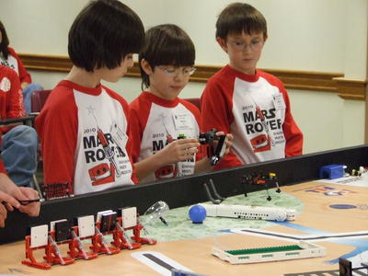
The growth of our FLL program into four new counties in 2010 is a direct result of our partnership with the NASA Educator Resource Center in Fairmont, WV and the statewide 4-H program. NASA provides MINDSTORM kits for new 4-H based FLL teams. The 4-H county leaders organize new teams and MARS team members travel to the NASA facility to mentor the 4-H teams. Through 4-H, we have the potential to engage every county of West Virginia in FLL. Just a year into this partnership, MARS is mentoring 4 new 4-H teams and is directly involved in creating the science and technology curriculum for local 4-H summer camps. The MARS-NASA-4H partnership will generate a sustainable statewide FLL program that will feed into new FTC and FRC teams. In time, we hope that through FIRST programs we will help change the culture of WV into one in which college attendance is expected, encouraged, and achieved by more WV students. At the local level, MARS has already had a significant impact on STEM education in the public schools. Through our partnership with the Board of Education, we have been able to create and implement a high school engineering class that is offered at a local high school for college credit and a local middle school is offering a robotics course.
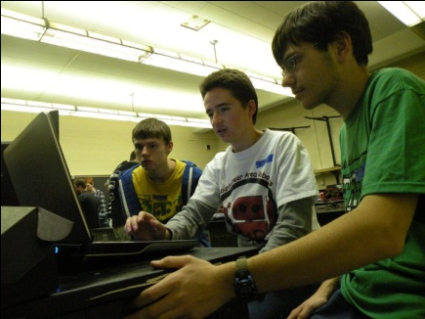
Having already established successful FLL programs across north-central WV, including one in very rural Preston County, MARS has helped launch FRC team 3492 (the RoboGens) in Winfield, WV. The development of team 3492 is a direct result of our team’s presentation at a summer engineering camp for rural and minority youth. Students who attended the camp convinced their teacher to start an FRC team. Our role has been to help the RoboGens organize their team, navigate the FRC registration process, gain sponsorship from JCPenney, and find ways to generate funds. They attended our 2011 season kickoff event and we continue to assist them with programming, electronics, and mechanical design. We have also brought together FTC team 2821 in Charleston, WV with the nearby RoboGens team so that 2821 can assist this rookie FRC team with construction of the mini-bot component of their 2011 robot. As we continue to work towards making FIRST available to every student in our state, we are intentionally forging connections and creating relationships between teams to ensure that there is a network of mutually supportive FIRST teams throughout WV.
It is important to realize that the geography of WV presents unique challenges in terms of collaborating with other FIRST teams. The closest WV FRC team to us is a four hour drive away in good weather. To overcome geographic barriers, our team has created the Appalachian Robotics Alliance, a statewide FIRST website to connect WV FLL, FTC, and FRC teams. Through forums on the web site, teams can exchange ideas and advice. In addition, people interested in FIRST can find out more about our state’s FIRST programs. We hope that this site will become the “Chief Delphi” for WV. The Alliance is another means that MARS is developing to help FIRST spread into rural communities.
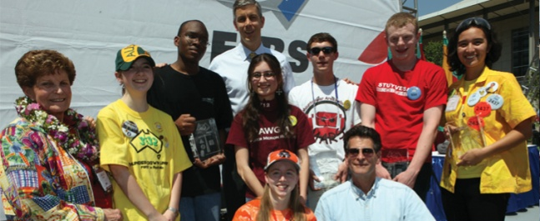
MARS has also worked every year to overcome barriers faced by members of the entire FIRST community. We have created the MARS SERTI (SEarch for Rookie Team Inspiration) Packet to provide assistance to rookie teams. This packet is available in three languages; English, Arabic, and Spanish. In 2009, we purchased and distributed Orbit Ball game pieces to teams as far away as Hawaii who were unable to obtain them locally. In 2009 and 2010, we participated in LabView and control system Beta testing and presented our findings to the Baltimore Alliance alongside FIRST team 1629. Last year, MARS graduate and 2010 Championship Dean’s List winner Luke Scime learned at his recognition ceremony that many sponsors of the FRC Kit of Parts desire recognition and feedback about how their parts are used and if they perform as intended. To meet this need, our team has created ThankFIRSTsponsors.org, a website that allows FIRST teams to post pictures of how they are using the sponsors’ parts and to thank the sponsors. FIRST sponsors can search the site by their company name and see the uploaded images and comments from the FRC community.
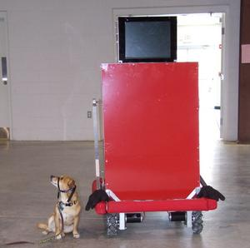
MARS partners with West Virginia University (WVU) and the Monongalia County Board of Education to provide summer programs for minority students and potential first-generation college students. We keep FIRST programs in the public eye through participation in local parades (our candy-throwing robot is a popular attraction and has made our shirts and our team community icons) and in charity events such as the Relay for Life and the Habitat for Humanity Triathlon. Our robot mascot, Marvin, has even walked dogs at a local animal shelter! In February 2011, a WV-PBS TV documentary showcased the MARS program to the entire state. We continue to work on Dean’s 2008 homework by inviting local media to MARS events. At the end of build season, we hold an open house to share our accomplishments with our sponsors, the media, and the community. By being a visible and active part of our community, our team gains support and recognition for FIRST while increasing the awareness of the need for STEM education.
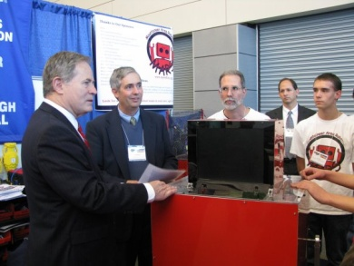
Through our non-profit, 501(c)(3) status, we have been able to develop strong financial connections with over 20 local sponsors. Our largest partner continues to be WVU, which provides us space, shop equipment, mentors and financial support. Our high-tech company sponsors have provided us not only with multi-year funding, but with mentors. Recently, MARS students have begun to serve as interns in those companies. In lieu of direct financial support, a local robotics-based company provided the team with thousands of pounds of used and new robot parts that we are now selling on eBay. The income we’ve generated from our robot parts and LED light bulb sales, combined with the donations of our sponsors, are used to support team members who need financial assistance to participate. Our partnerships have helped us to develop a strong community base that ensures that MARS students can participate in FIRST regardless of their financial situations. All team members participate in build season, fundraising, and community outreach and are given financial support to attend regional events.
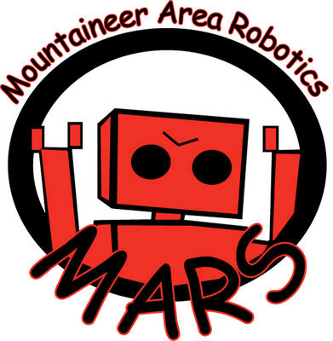
We are creating a path to and an expectation for higher educational success in WV. We are building and connecting FIRST teams throughout the state. We are the mentors and the catalyst for a flourishing FLL program that in just 3 years has spread to nearly 1/5 of West Virginia’s counties. We are community program that provides a way for local youth to explore STEM fields. We are developing community partnerships that help us overcome financial barriers. We are the catalyst for local STEM educational initiatives. We are forging unique paths to cross geographical barriers in West Virginia. We are answering the call of the national FIRST community. We are developing a plan to expand sustainable FIRST programs in rural areas. We are MARS.

